5 in a row peer to peer game

ECE463/CSCI436

Sara York
0003131021
sarayork@umail.iu.edu

Josh Greer
0003014083
josgreer@umail.iu.edu

11/25/16

Introduction

The report into sections to make clear the processes while working on the project and to describe what each group member worked on. First, the sections are divided into groups that follow the build process of the project starting from initial ideas to the end product. Then the report will introduce sections for each group member to discuss what part of the project they worked on and their thoughts.

Planning

There were a lot of ideas to choose from in the initial planning of the project and how to implement peer to peer sharing of a real time game connection. The first test was to try to understand how to set up a peer to peer connection by sending strings back and forth. There were problems in the beginning trying to set up the connection and have the two host acknowledge each other to exchange information. After looking into documentation for node.js and peer.js, it was easier to work with and see how the two establish connections. Node.js was not the right tool to use since its mostly used for single user use and not connecting two peers.
After figuring out what peer to peer tool to use to establish the connections the game needed to begin being coded and tested across a peer to peer connection. The game is on a 5x5 board as shown in Figure 1. The yellow highlights help show diagonals in the game board to make sure all the winning combinations are included in the list of arrays.
This game is similar to a previous project made for another class so it was reused and adapted for peer to peer sharing and to be played on a larger game board.

0 | 1 | 2 | 3 | 4
5 | 6 | 7 | 8 | 9
10 | 11 | 12 | 13 | 14
15 | 16 | 17 | 18 | 19
20 | 21 | 22 | 23 | 24
Figure 1

Game play

In the peer to peer game you start a game connection with both hosts, A and B, opening a fiveinarow.html file in their browser. One host, A for example, will open the html file to start a game. Then, host B needs to open the file and choose “join” or “create”. Join will prompt user B to then type in the ID for host A, so this requires some human communication to let each other know what the ID’s are. The ID’s are what let the server know which two hosts want to connect to each other. Once the connection is established the game will begin. Your screen will notify you when it is your turn to go.
If you are the starting player you place your piece on any of the twenty-five squares. Then the game will watch for that click in the game board and end your turn after placing your piece. After that it will be the other hosts turn and the game will continue until one person gets five in a row.

Code implementation

function Cell:
This function sets up the game board to be blank initially and loads in all the sprite images for the pieces. It also includes the cell check for a click on a cell. As long as the cell is blank it will replace the blank cell with the player piece depending on whose turn it is.

Function buildCells:
This function is responsible for replacing the cell that was clicked with the image in the correct position on the game board.

Funciton updateCells:
This function checks for already clicked cells and cells that need updated with a player piece if clicked.

Function setupData:
This function contains the array of winning arrays and the player names, X and O for example. The winning arrays are all the possible values on the game board cells that would make a winning five in a row combination. So, all the horizontal, vertical and diagonal winning combinations on the game board are stored here and reference by the checkWin function after each click.

Function checkWins
This function is called to check for a winner. It compares the values clicked with the set of winning arrays to see if someone got a five in a row win. If the cells clicked have matching sprites in the arrays that are defined in the winning arrays then that player wins. So in the for loop we assign variables a,b,c,d,e to cell locations to check for every cell. Then it compares the values to the player that claims that cell and if they are all the same five in a row then a winner will be declared.

Function init:
This function places the game board on screen with its set size. It also sets up the individual cells to the game knows where a player clicks what cell its clicking in. It begins by prompting for the “join or create a new game” prompt, where the player types “join” or “create”. Then depending on the text input it will put the hosts into different modes.

Function update:
This function sets up the connection between the two host to make sure they are connected.
It also checks the cells and updates them to make sure there is a winner. Once there is a winner it flashes a winning message.

Project contribution

Sara York:
Sara worked on the game board and sprite images for the game and research into peer to peer sharing between two hosts and how to implement it. She also prepared the report for the project and analyzed what the code sections do. Together she and Josh worked through any bugs encountered and any ways to make the code simpler.

Josh Greer:
Josh built the code based off of previous assignments and modified to fit a five by five board and coded the sections for the peer.js connection. He also reviewed the report and set up the wireshark to capture the connection between the two hosts.
Issues

There are some issues with the functionality of the game but the peer to peer connection does work and both hosts can communicate with each other. It is easy to find what needs to be added in order to have a full working turn based game but due to time constraints the functionality of the game isn’t there.
IN order for the game to work correctly there needs to be added a turn handler for the player and data sent between the two hosts. The data that would be sent is the clicked array spot. Then on the opponents board the code should be able to handle updating each hosts board with the players token that the host clicked on. If given more time the game would be nearly perfect.
The game does send the string “hi” back and forth between the two hosts when a tile is clicked. The only major problem is the game board not behaving correctly for a turn based peer to peer game.

Wireshark capture

Below is the screen capture of a click on a tile of one host and the response from the other host.
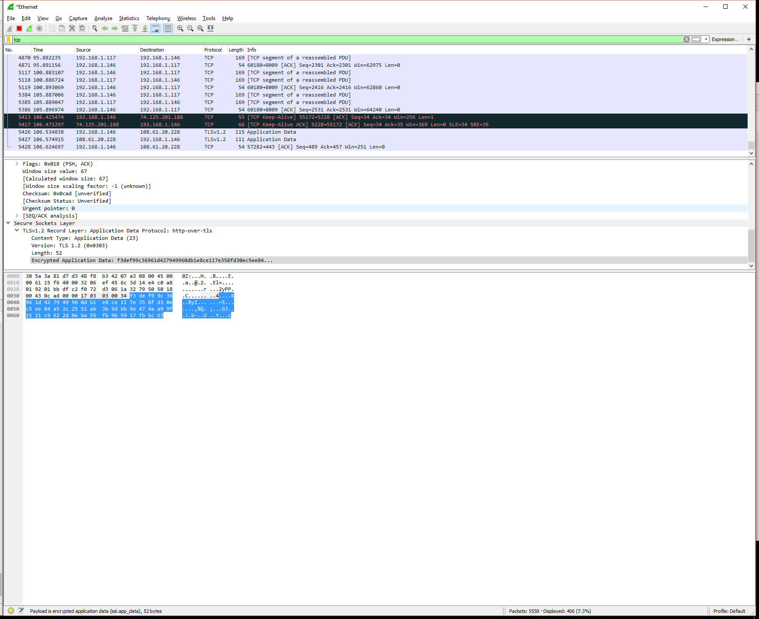

Documentation

http://peerjs.com/docs/#start
http://blog.modulus.io/absolute-beginners-guide-to-nodejs
https://www.toptal.com/webrtc/taming-webrtc-with-peerjs

